**Bug Report**

**Defected ID**: 01 **Severity – High Priority High**

**Description:** In some languages, the user can’t translate the voice. mic icon displays in disable mode.

**Test Steps:**1. Click the link or Copy and paste the link

2. Click mic icon

**Expected Result:** Should translate the voice.

**Actual Result:** Pop up error message “voice input isn’t available for Maori” mic icon displays in disable mode. (Arish, Maori, Shona….etc languages do not translate the voice mode.)

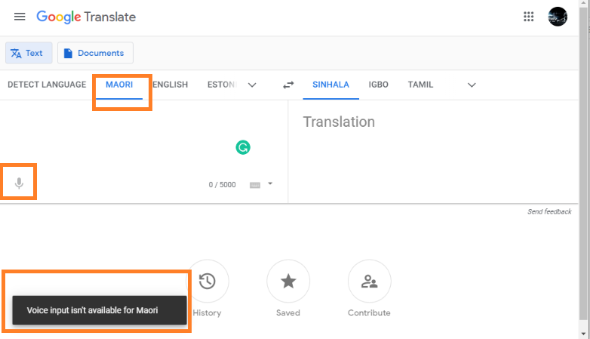

**Test Data:** input voice **“**You are required”

**Assigned to** – Developer who create the respective part

**Reported by** – Janith

**Bug:** open

**Reported On** – 25/05/2021